Day Torip to Wenchi Crater Lake
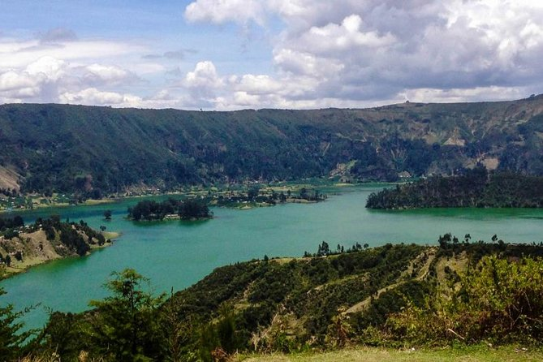
Duration- Full days
Mode of transportation: - Car
Wenchi Crater Lake
You will pick from the hotel or airport, looking for a day trip outside of Addis Ababa, to Wenchi Crater Lake is a nice choice for spending your day vacation. Wenchi Crater Lake is 155 km west of Addis Ababa, between Ambo and Weliso. An extinct volcano, the top of which is 3380 meters above sea level, is a crater that contains a large lake, hot mineral springs, waterfalls, beautiful valleys and farmland. There is an old monastery with a church situated on one of the lake islands. so you will have about experience. After the visit return to Addis Ababa

